HOW TO CREATE KUBERNETS DASHBOARD

1. Deploy kubernetes dashboard

kubectl apply -f https://raw.githubusercontent.com/kubernetes/dashboard/v2.0.0-beta8/aio/deploy/recommended.yaml

1. Kubectl –n Kubernetes-dashboard get all
2. Kubectl –n Kubernetes-dashboard edit svc Kubernetes-dashboard

Edit the file service file change the type 🡺 NodePort

1. Vi ca-admin.yml

|  |  |
| --- | --- |
|  | apiVersion: v1 |
|  | kind: ServiceAccount |
|  | metadata: |
|  | name: dashboard-admin |
|  | namespace: kube-system |
|  | --- |
|  | apiVersion: rbac.authorization.k8s.io/v1beta1 |
|  | kind: ClusterRoleBinding |
|  | metadata: |
|  | name: cluster-admin-rolebinding |
|  | roleRef: |
|  | apiGroup: rbac.authorization.k8s.io |
|  | kind: ClusterRole |
|  | name: cluster-admin |
|  | subjects: |
|  | - kind: ServiceAccount |
|  | name: dashboard-admin |
|  | namespace: kube-system |

1. Kubectl apply –f ca-admin.yml
2. Kubectl –n kube-system describe sa dashboard-admin

Execute the above command and copy the token

1. Kubectl –n kube-system describe secret copythetoken

By executing the above command it will generate token copy the token

1. Kubectl get nodes –o wide 🡺 copy anyone node external ip address

<https://nodeipaddress:31143>

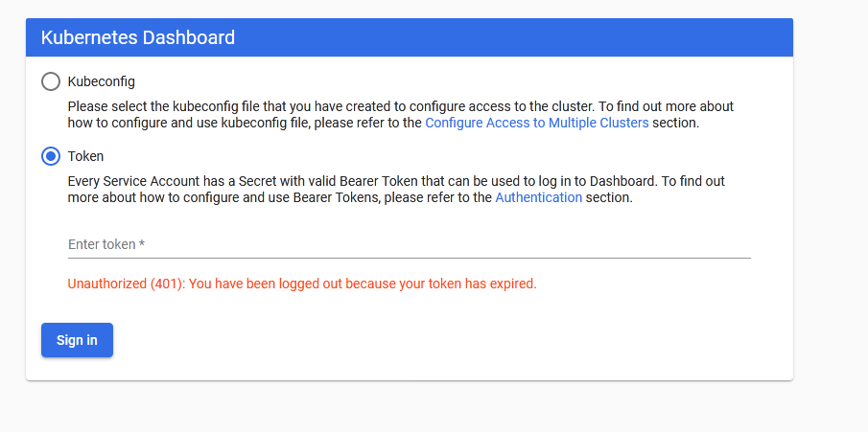

Paste copy the token above